Department: Computer Science Program: BS (CS)
DBMS (Theory)
Announced date: 14-Jan-2026 |  |  | Due Date: 21-Jan-2026 |  | Total Marks = 10
 | Complex Computing Problem (CCP)
 | Mapped CLO | SDG |  | Complex Problem Solving Mapped
 | CLO2, GA5, C3 | 9 |  | WP3 (Depth of knowledge required)  WP1 (Range of conflicting requirements required)  WP2 (Depth of analysis required)

Group Members:
- Muhammad Zaeem Rehman (IU04-0123-0465)
- Muhammad Uzair Baig (IU04-0123-0)
- Muhammad Ghufran (IU04-0123-0200)

Title: Design and Implementation of a Multi-Collection MongoDB-Based Data Management System Using CRUD Operations
Problem Statement:
Traditional library record management systems are often inefficient, error-prone, and difficult to maintain when handling large volumes of data. There is a need for a reliable database system that can efficiently store, retrieve, update, and delete library-related information. This project aims to develop a Library Management System using MongoDB to perform CRUD operations, ensuring organized data management and improved system performance.

Constraints/Assumptions

- MongoDB is used as the primary database engine for the system.
- The database consists of multiple collections such as Books, Customers, Branches, Employees, and IssueStatus.
- Each document contains a unique identifier to ensure data uniqueness.
- At least one collection contains a large number of documents to represent realistic data.
- Both embedded documents (e.g., book issue details) and referenced documents (e.g., customer and book references) are used.
- CRUD (Create, Read, Update, Delete) operations are performed on multiple collections.
- Queries include conditions, projections, and access to nested fields.
- The data represents a realistic library management scenario, including book issuing and returning.
- Basic validation is assumed, and advanced security features are not implemented.

Expected Outcomes:
Students must design, implement, and analyze a MongoDB-based system using the following tasks.

Database and Collection Design

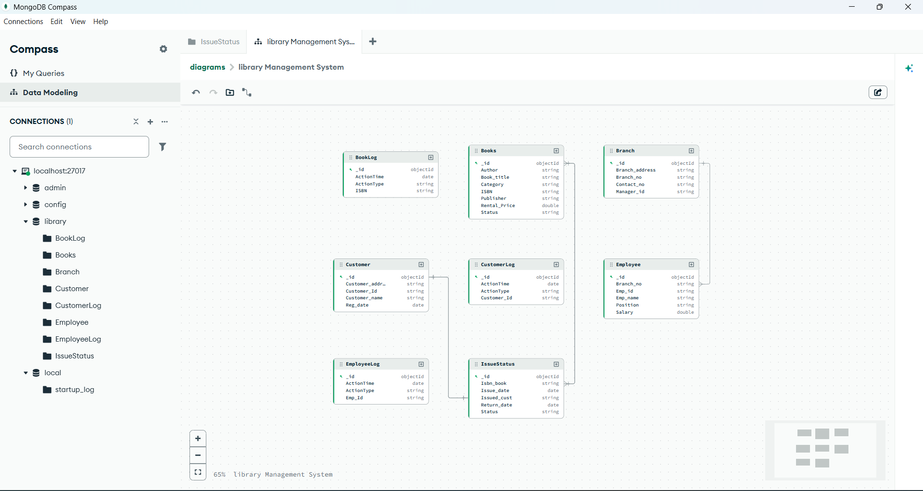

Data Population (Create Operations)

db.createCollection("Customer_Info");
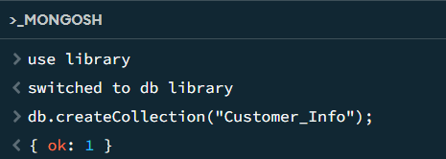

Read Operations (Querying & Filtering)

db.Customer.find().pretty()
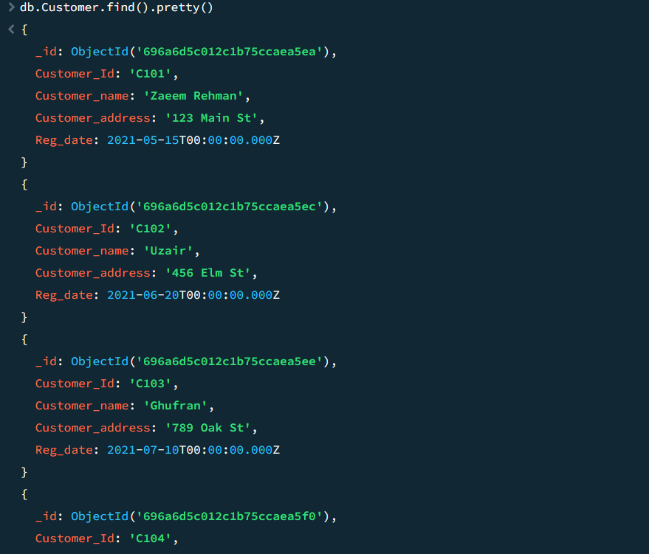

Update Operations

db.Customer.updateOne(
{ Customer_Id: "C101" },
{ $set: { Customer_name: "Zaeem Rehman" } }
)
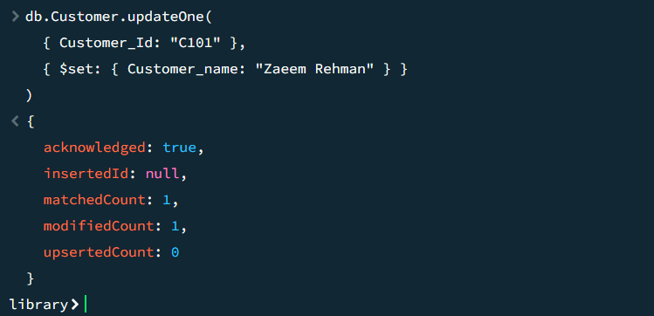

Delete Operations

db.Customer.deleteOne({ Customer_Id: "C106" })
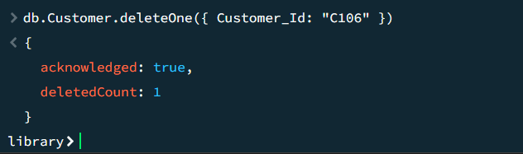

F. Query Validation and Testing

- Create (Insert)
db.Books.insertMany([
{
ISBN: "978-0-123-45678-9",
Book_title: "The Hobbit",
Category: "Fantasy",
Rental_Price: 6.1, // double type
Status: "Yes",
Author: "J.R.R. Tolkien",
Publisher: "HarperCollins"
},
{
ISBN: "978-0-987-65432-1",
Book_title: "Thinking, Fast and Slow",
Category: "Psychology",
Rental_Price: 7.5, // double type
Status: "Yes",
Author: "Daniel Kahneman",
Publisher: "Farrar, Straus and Giroux"
}
]);

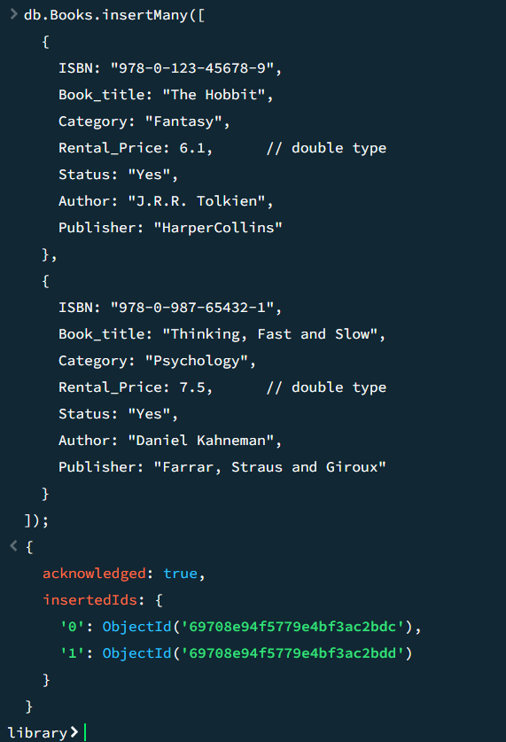

- READ (Query)
db.Books.find().pretty();
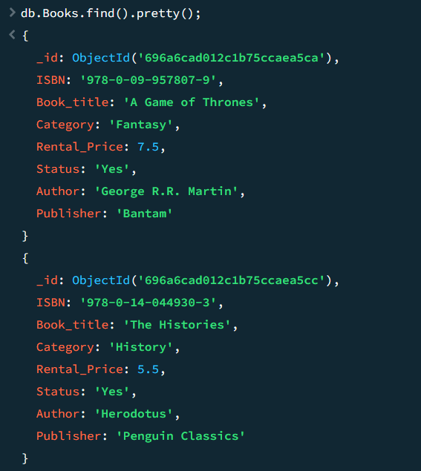

- UPDATE
db.Books.updateOne(
{ ISBN: " 978-0-7432-7357-1" },
{ $set: { Rental_Price: 6.0 } });
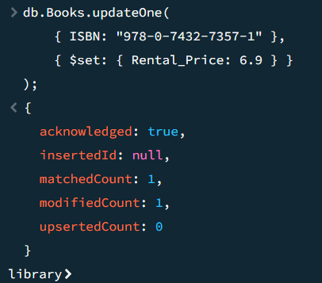

- Delete
db.Books.deleteOne({ ISBN: " 978-0-7432-7357-1" });
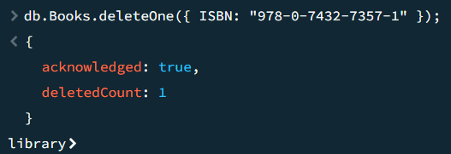

G. Real-World Applicability
This CCP models real-world database systems such as:
- Library Management Systems for schools, universities, and public libraries
- Digital Book Rental and Tracking Systems
- Student/Customer Information Management Systems
- Inventory and Asset Management for book collections
- Branch and Employee Management Systems
- Cloud-based or NoSQL-enabled library applications for scalable access

Performance Metrics
- Conceptual Understanding
Evaluate how well students understand MongoDB’s document-oriented data model in the context of library data (books, customers, branches, employees, and issue records).
- Technical Accuracy
Correct use of CRUD operations, operators, and document structures for managing books, customers, branches, and issue/return transactions.
- Analytical Depth
Ability to analyze data modeling choices, schema validation, and query outcomes, such as book availability or customer borrowing history.
- Problem-Solving Efficiency
Handling real-world constraints such as data consistency (status of issued/returned books), avoiding redundancy, and updating multiple related documents efficiently.
- Validation Capability
Ability to test, verify, and explain CRUD operation results using sample queries, logs, and schema validation.

Deliverable:

Category | Deliverables
Conceptual | MongoDB database schema design with justification
Implementation | MongoDB CRUD scripts for all collections
Report | Detailed documentation of collections, sample documents, CRUD queries, and outputs

CCP Attributes mapped
Attributes of Complex Problem Solving |  | Justification
WP | Description | Theory of automata CCP Mapping
WP3 | Depth of Knowledge | Requires understanding of MongoDB data modeling, embedded documents, references, and CRUD operations
WP1 | Range of Conflicting Requirements | Balancing schema flexibility, data duplication, and query efficiency
WP2 | Depth of Analysis | Analyzing CRUD behavior, nested queries, and document relationships

